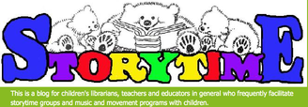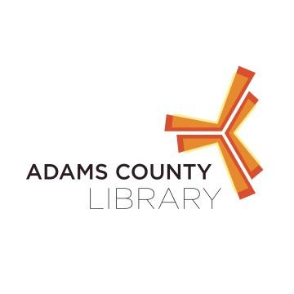

**Baby Storytime**

**Mondays 9:30 AM- 10:00 AM**

Join us for books, songs, nursery rhymes, and more!

**Toddler Storytime**

**Mondays 10:30AM-11:00AM**

Join us for stories, music, movement, finger plays, and more!

**ADAMS COUNTY LIBRARY SYSTEM- NEW OXFORD**

**122 N. Peters Street Phone 717-624-2182**

**New Oxford, PA 17360 Fax 717-624-1358**