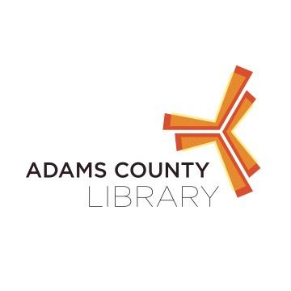

**Mark DeRose Music at New Oxford Area Library**

Mark DeRose has a lot of experience in music from opening for major music acts such as Michelle Branch and Josh Kelly to playing bass for children’s music. Come to New Oxford Area Library to experience Mark’s solo Childrens music which combines his love of visual arts along with his love of music to create a fun experience.

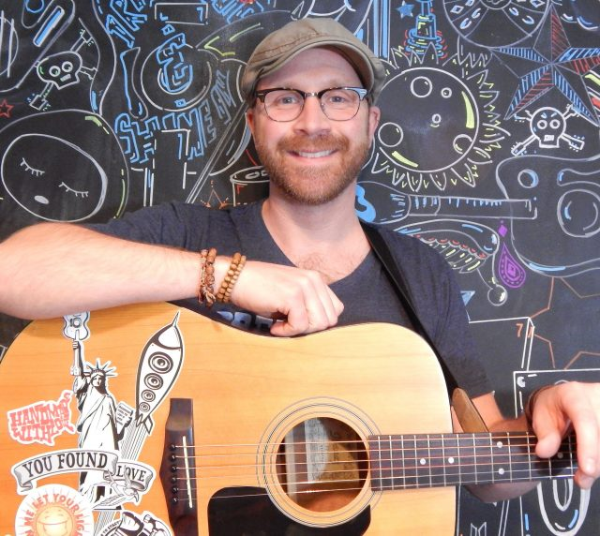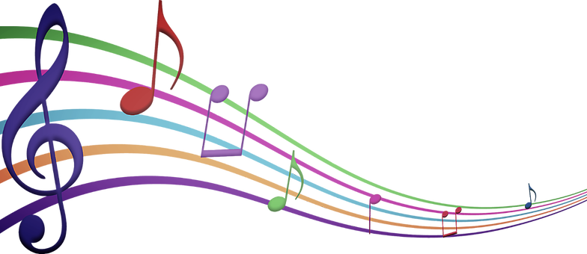

When: June 14th @ 6:30 PM

Where: New Oxford Area Library

122 N. Peter Street, New Oxford PA

Who: Kids of All Ages

For questions contact the library at 717-624-2182